

**MECHATRONICS SYSTEM INTEGRATION (MCTA 3203)**

**SEMESTER 1 2024/2025**

**WEEK 6: DAQ-MC INTERFACING**

**SECTION 2**

**GROUP 8**

**LECTURER: ZULKIFLI BIN ZAINAL ABIDIN & WAHJU SEDIONO**

| NO. | GROUP MEMBERS | MATRIC NO. |
| --- | --- | --- |
| 1. | AHMAD DARWISH BIN AHMAD TERMIZI | 2212089 |
| 2. | SYABAB ALHAQQI BIN JAAFAR | 2211117 |
| 3. | WAN NAIMULLAH BIN MOHD AZRUDDIN | 2214837 |
| 4. | ZAIMUDIN ZAKWAN BIN NORZAMRI | 2217513 |
| 5. | ZAMIR MUTTAQIN BIN MUHAMMAD BALYAN | 2212985 |

Date of Experiment: Wednesday, 13 November 2024

Date of Submission: Wednesday, 20 November 2024

## **ABSTRACT**

This experiment explored the integration of sensors with an Arduino microcontroller for real-time data acquisition and analysis. The primary objective was to collect and log sensor data into a spreadsheet using PLX-DAQ software and visualise the results effectively. The methodology involved validating and uploading the Arduino code while setting up communication with the PLX-DAQ software and creating informative plots from the collected data. The results showcased accurate data logging and visualisation, demonstrating the feasibility of using Arduino and PLX-DAQ for real-time monitoring applications. This experiment highlights the potential for scalable applications in IoT and automation systems.

TABLE OF CONTENTS

| NO | CONTENT | PAGE |
| --- | --- | --- |
| 1 | INTRODUCTION | 4 |
| 2 | MATERIALS AND EQUIPMENTS | 5 |
| 3 | EXPERIMENTAL SETUP | 5 |
| 4 | METHODOLOGY | 6 |
| 5 | DATA COLLECTION | 7 |
| 6 | DATA ANALYSIS | 7 |
| 7 | RESULTS | 8 |
| 8 | DISCUSSION | 8 |
| 9 | CONCLUSION | 8 |
| 10 | RECOMMENDATIONS | 9 |
| 11 | REFERENCES | 9 |
| 12 | ACKNOWLEDGEMENT | 9 |
| 13 | DECLARATION | 10 |

## **INTRODUCTION**

This experiment explores the implementation of a simple data acquisition (DAQ) system using an Arduino microcontroller to collect and transfer data from an LDR (light sensor) and an LM35 (temperature sensor) to a computer via PLX-DAQ software. The analog signals from the sensors are converted into digital format by the Arduino and logged in an Excel spreadsheet for visualization and analysis. This hands-on activity demonstrates the integration of sensors with microcontrollers and the use of real-time data logging tools for effective measurement and analysis.

## **MATERIALS AND EQUIPMENTS**

1. ARDUINO MEGA 2560
2. PLX‐DAQ
3. LDR
4. LM35
5. JUMPER WIRES
6. RESISTOR
7. BREADBOARD

## **EXPERIMENTAL SETUP**

1. LDR Connection:
   * One leg of the LDR is connected to 5V.
   * The other leg is connected to a voltage divider using a 10k resistor.
   * Connect the junction of the LDR and resistor to an analog input pin A1.
   * The other end of the resistor is connected to GND.
2. LM35 Connection:

* VCC connect to 5V.
* OUT connect to another analog input pin A0.
* GND connect to GND.

1. Additional Setup:

* Connect the Arduino Mega 2560 to your computer using a USB cable.
* Ensure the breadboard connections are stable.

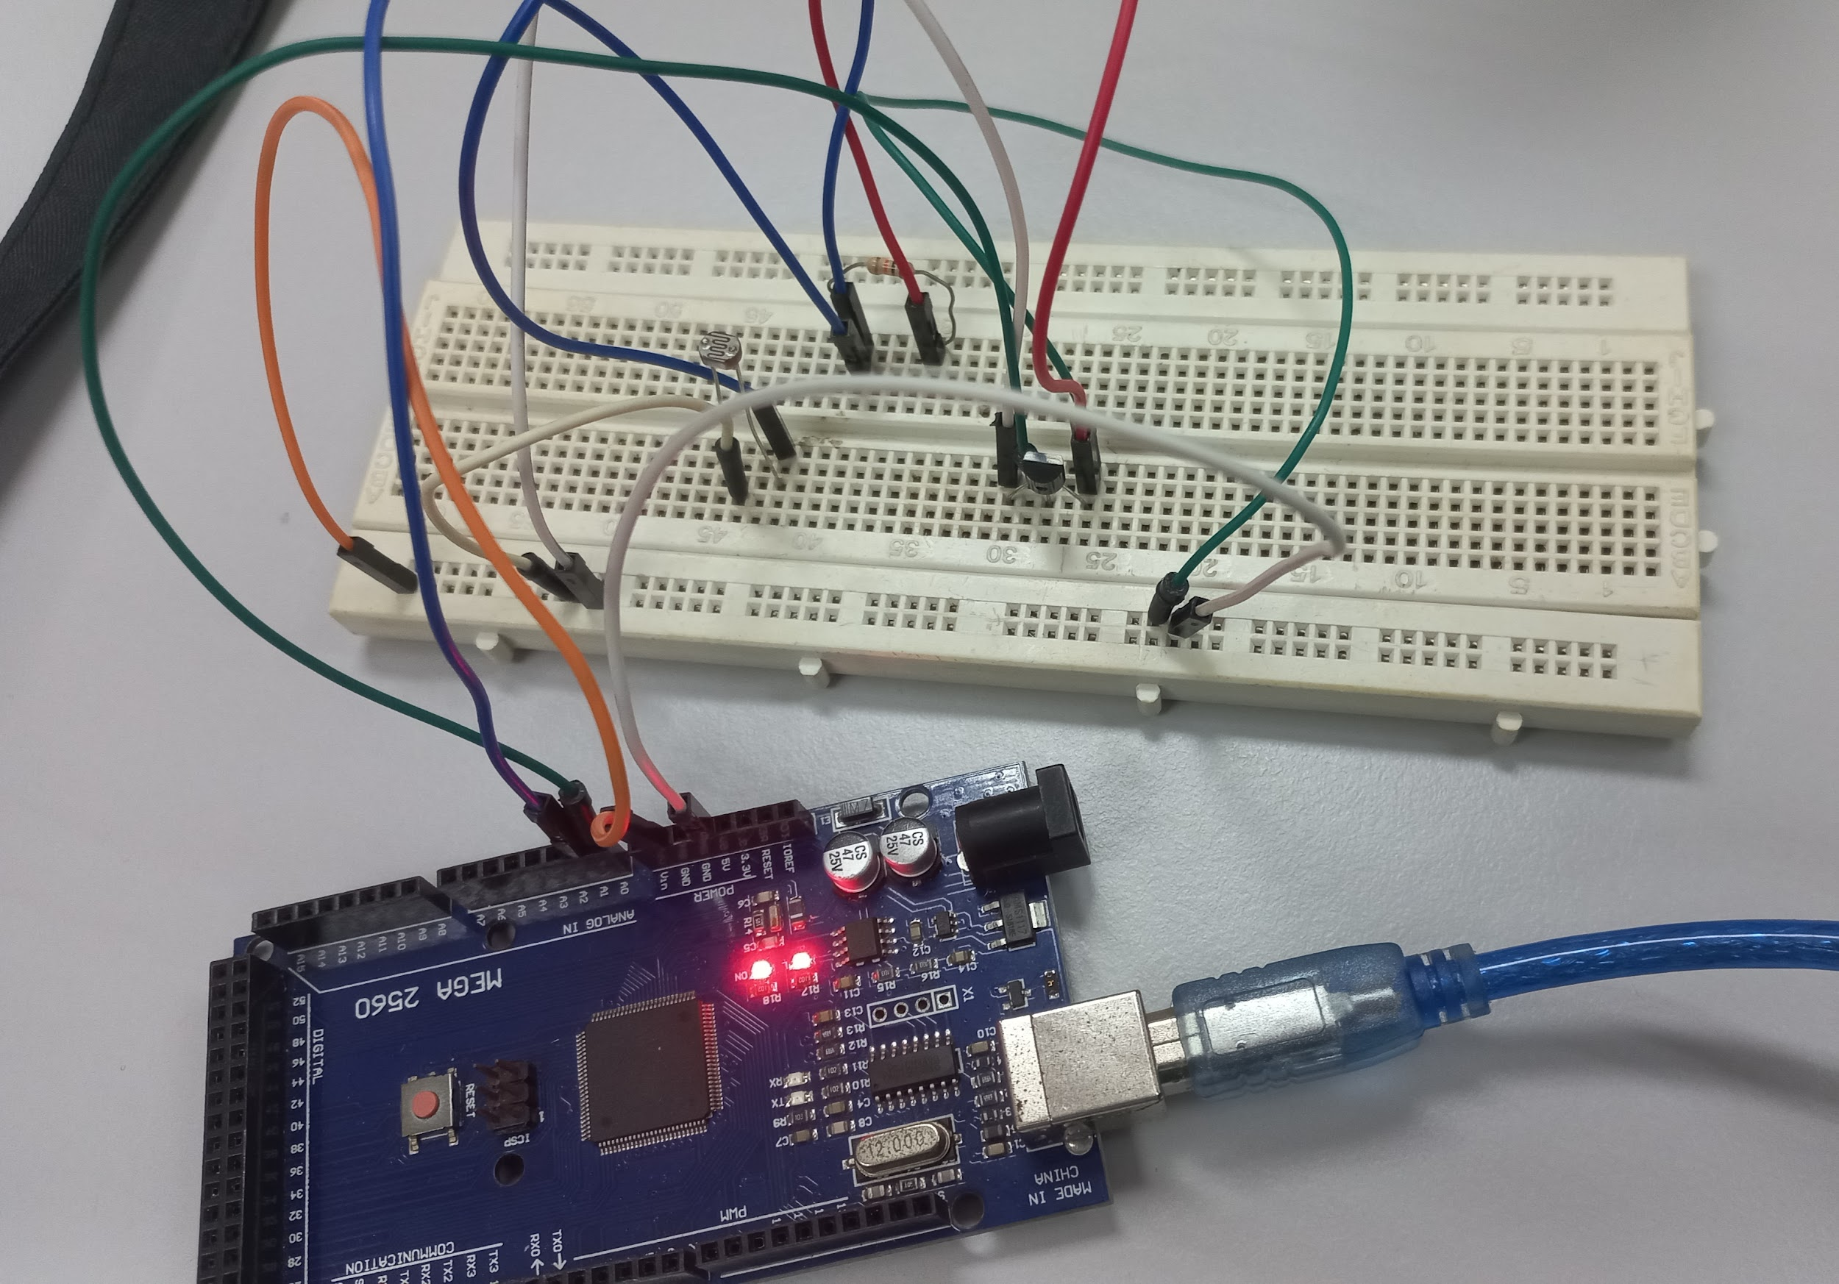

## Figure 1: Experimental Setup

## METHODOLOGY

1. Setup the Arduino Mega 2560, LM35 and LDR sensor
2. Code implimentation
3. Testing
4. LDR will react to light intensity
5. LM35 will react to temperature
6. The data will be shown in excel
7. Code snippet

**Arduino Code**

float tempcelc;

float lm_value;

int ldr_value;

int ldr_percent;

void setup() {

Serial.begin(9600);

Serial.println("CLEARDATA");

Serial.println("LABEL, CLOCK, TEMPERATURE, LIGHT");

}

void loop() {

lm_value = analogRead(A0);

tempcelc = (lm_value/1023)*5000;

tempcelc = tempcelc/10;

ldr_value = analogRead(A1);

ldr_percent = map(ldr_value, 0, 1023,0,100);

Serial.print("DATA, TIME,");

Serial.print(tempcelc);

Serial.print(",");

Serial.println(ldr_percent);

delay(1000);

}

**DATA COLLECTION**

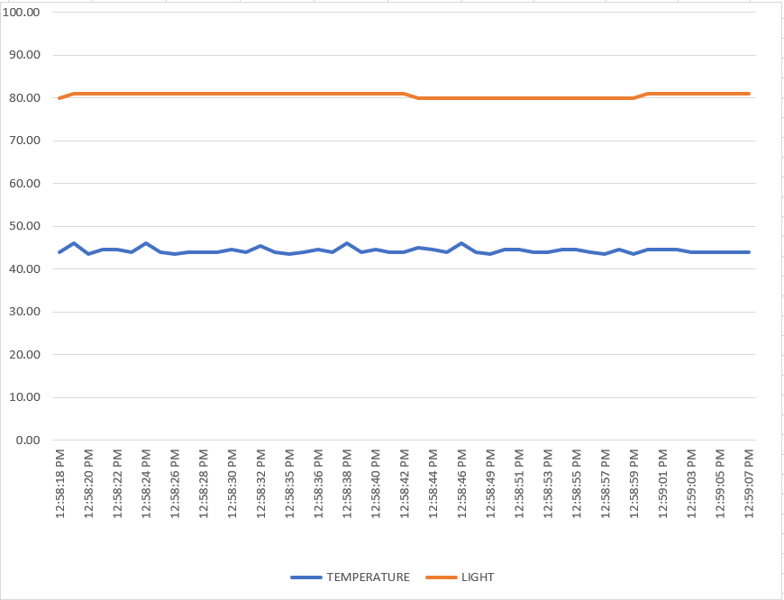

**DATA ANALYSIS**

From data that we collect:

1. LDR Sensor Performance

* The LDR output showed noticeable oscillations in response to changes in ambient light intensity.
* The data patterns were consistent and predictable, as seen in Excel graphs.

1. LM35 Sensor Performance
   * The LM35 provided stable and accurate temperature readings in degrees Celsius
   * The temperature data exhibited minimal noise or drift.
2. Data Accuracy
   * Observed values generally aligned with expected results under controlled conditions.
3. Noise and Discrepancies
   * Consistent discrepancies across trials suggest the need for noise reduction
   * techniques, such as capacitors, to enhance signal clarity.

## RESULT

The experiment successfully demonstrated the integration of the LDR and LM35 sensors into a data acquisition system using an Arduino microcontroller. Real-time data from the sensors was transmitted to the PLX-DAQ interface and logged into an Excel spreadsheet. The LDR readings varied according to changes in ambient light intensity, while the LM35 provided consistent temperature readings in degrees Celsius. The data was accurately recorded in tabular format and subsequently visualised using Excel plots, which revealed clear trends corresponding to environmental changes. These results validated the functionality of the constructed circuit and the accuracy of the Arduino-based DAQ system.

## DISCUSSION

The results of the experiment demonstrated successful real-time data acquisition and analysis using Arduino and PLX-DAQ software, confirming the system's reliability and efficiency. However, minor discrepancies were noted between the expected and observed outcomes, which may be attributed to factors such as sensor calibration errors, environmental noise, or variations in the communication latency between the Arduino and the PLX-DAQ platform.

Additionally, the experiment faced limitations in terms of the resolution and frequency of data logging, which were constrained by the performance of the PLX-DAQ software and the Arduino's processing capabilities. Future experiments could explore optimising these parameters and employing higher-quality sensors to improve accuracy and reliability. Despite these limitations, the results reinforce the practicality of Arduino-based data acquisition systems for real-time monitoring applications.

## CONCLUSION

This experiment successfully demonstrated the integration of sensors with an Arduino microcontroller and the use of PLX-DAQ software for real-time data acquisition and analysis. The main findings highlighted the system's ability to accurately capture and log sensor data while visualising it effectively and aligning well with the expected outcomes.The results supported the hypothesis by confirming that the Arduino and PLX-DAQ setup is effective and reliable for real-time monitoring and analysis tasks. The plots generated from the data provided valuable insights into the behaviour of the sensors, showcasing their performance under varying conditions.

These findings have broader implications in areas such as IoT, automation, and environmental monitoring. The experiment underscores the potential for scalable applications in real-time data acquisition and analysis by providing a foundation for advancements in smart systems and industrial processes.

## RECOMMENDATIONS

Several recommendations are made to improve the experiment's results and future outcomes. First, frequent calibration of the LDR and LM35 sensors is required to reduce mistakes caused by sensor drift or imperfections and ensure accurate data gathering. Furthermore, adding capacitors across the sensor outputs to the ground will assist in filtering out electrical noise, boosting the stability and accuracy of data. Upgrading data logging capabilities by looking at alternatives to PLX-DAQ, such as MATLAB or a specialized DAQ device, can result in higher resolution and quicker data acquisition rates. Conducting the experiment in a controlled setting is also recommended to reduce extraneous disturbances such as variable light sources or temperature fluctuations, which might alter findings.

## REFERENCES

* PLX-DAQ **-** <https://www.youtube.com/watch?v=WHuOUyq5CpY&t=2s>
* Arduino IDE
* Texas Instruments. (n.d.). LM35 precision centigrade temperature sensor
* Electronics Tutorials. (n.d.). Light-dependent resistors (LDRs) and their applications. Retrieved from [https://www.electronics-tutorials.ws.](https://www.electronics-tutorials.ws)

## ACKNOWLEDGEMENTS

Special thanks to ZULKIFLI BIN ZAINAL ABIDIN & WAHJU SEDIONO for their guidance and support during this experiment.

**Certificate of Originality and Authenticity**

This is to certify that we are **responsible** for the work submitted in this report, that **the** **original work** is our own except as specified in the references and acknowledgement, and that the original work contained herein have not been untaken or done by unspecified sources or persons. We hereby certify that this report has **not been done by only one individual** and **all of us have contributed to the report**. The length of contribution to the reports by each individual is noted within this certificate. We also hereby certify that we have **read** and **understand** the content of the total report and no further improvement on the reports is needed from any of the individual’s contributors to the report. We therefore, agreed unanimously that this report shall be submitted for **marking** and this **final printed report** has been **verified by us.**

Signature: darwish Read [/]

Name: AHMAD DARWISH BIN AHMAD TERMIZI Understand [/]

Matric Number: 2212089 Agree [/]

Contribution: Introduction, Result

Signature: syabab Read [/]

Name: SYABAB ALHAQQI BIN JAAFAR Understand [/]

Matric Number: 2211117 Agree [/]

Contribution: Experimental Setup, Methodology, Recommendations

Signature: naim Read [/]

Name: WAN NAIMULLAH BIN MOHD AZRUDDIN Understand [/]

Matric Number: 2214837 Agree [/]

Contribution: Abstract, Material and Equipments, Conclusion

Signature: zaim Read [/]

Name: ZAIMUDIN ZAKWAN BIN NORZAMRI Understand [/]

Matric Number: 2217513 Agree [/]

Contribution: Data Analysis,References

Signature: zamir Read [/]

Name: ZAMIR MUTTAQIN BIN MUHAMMAD BALYAN Understand [/]

Matric Number: 2212985 Agree [/]

Contribution: Data Collection